FOR SALE! 1962 Cessna 310G “Anniversary Edition”
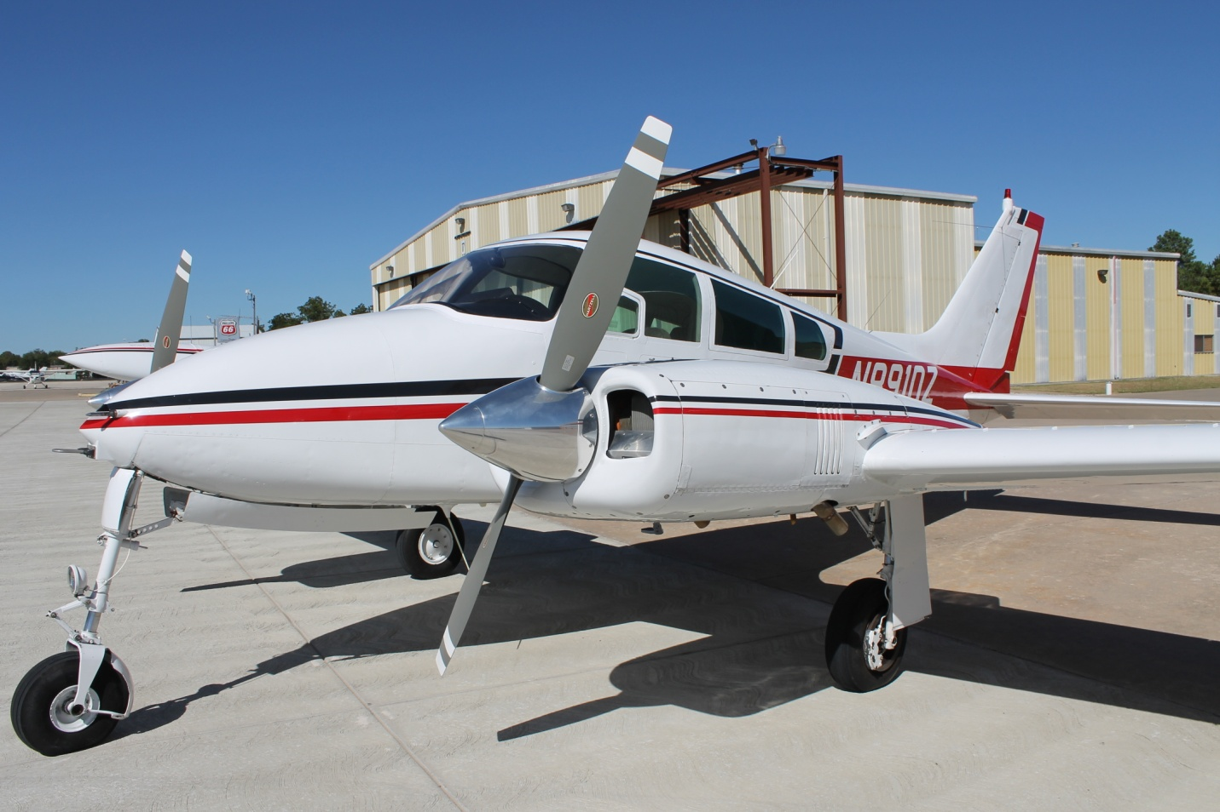

Total Time- 5131
Engines- Continental IO-470-D 260hp
L/SMOH- 252 hrs Overhauled in 2007
R/SMOH- 1202 hrs Overhauled in 1992

Props- Hartzell HC-C2YF-2CUF AD free 2-Blade Propellers
Both- 283 hrs Since New
*Scroll down for detailed specs and info*

Avionics:
- King KLN94B IFR approved Color Moving map GPS
- King Dual KX155 Nav/Coms
- King KN64 DME
- King KT76 Transponder
- PS Engineering 4pl Intercom with passenger control boxes and stereo jack
- IFR Cert and Transponder current until July 2014

Exterior- Stripped and repainted in Jet-Glo (1998). Still in fantastic condition and shows beautifully. I keep the airplane very clean and it gets waxed twice a year. I usually clean the underside of the airplane once a month and remove all the exhaust soot as well. No hangar rash.
Interior- All new gorgeous leather interior installed (2007). Most of the interior is exactly what went into the new Cessna 206. Brand New headliner. New plastic and glareshield. New Carpet. Has 4 place seating installed at this time and comes with a 5th seat that can be installed if you wish. All seats recline and have arm rests. This is a very comfortable airplane on long trips.

* This is one of the nicest 310’s in the world for its age. It has had excellent maintenance its whole life and has been well taken care of by its owners. It has been maintained by TAS aviation and Yingling recently (Best Twin Cessna shops in the country). In the last 10 years it has had many parts overhauled or replaced. Myself, and the previous owner have turned this into a very safe and comfortable airplane that won’t need much for years to come. It has every mod that a 310 needs to have. It is only 1 of a couple 310’s that has a spar strap. We keep up with landing gear maintenance religiously and every year follow along with the Twin Cessna Flyer recommended gear rigging material. We keep up with Service Bulletins and the airplane only has a couple AD’s that apply. The engines run fantastic and I rarely have to add oil between oil changes (30hrs). CHT’s run nice and cool even in the summer. This 310 is always hangared and only sits outside on occasion. Have all original logbooks with the most recent being on ADLOG. All the paperwork is complete and comes with all the maintenance manuals, parts catalogs, gear rigging tools and manuals. Also comes with a full cabin cover.

** I have owned this 310 for 4.5 years and enjoyed every second of it. I have flown it all over the place and it’s never let me down. I flight plan for at least 175kt TAS and average 25gph total. I normally see ground speeds in excess of 180kts and the airplane does great above 10k feet. This 310 has the two 15gal aux tanks which give a total fuel capacity of 130gal. I normally get around 700-800 nm range. The airplane does not have an autopilot, but has never been an issue for me. This 310 is rigged perfect, trims up very nice and makes hand flying a breeze.
Useful load is approx. 1700lbs and will carry about anything you can fit thru the door. I take it to Oshkosh every year and with 2 people, full tanks and a week’s supply of camping gear I’m still below gross weight. I’ve flown it out of the mountains of Colorado multiple times (7700ft Elevation) and it climbs right to 13k at 700ft/min, and I’ve gone straight to 17.5k where it will cruise along at 160kts+ TAS sipping 22gph. I fly this airplane very conservative. I never shock cool the engines. I run 50-75deg rich of peak and NEVER run LOP. I baby the landing gear minimizing side loads on the mains and keeping stress off the nose gear. This airplane has not been abused. The airplane has lived its whole life away from salt air and the majority of the time it’s been based in the Midwest. The airplane is extremely clean inside of any corrosion and has been treated with ACF50.
Mods/Upgrades/STC’s:
1.) Wing Spar Strap- (2005)
Cessna Service Kit 310-115.Performed by Yingling aviation and Cessna. One of only a couple 310’s in the world with this mod. Included a very in-depth wing and carry thru inspection. Full report in aircraft paperwork. (This is approx. a $35,000 mod) if the 400 series wing spar AD ever y trickles down to the 310’s then you’re already covered.

2.) Vortex Generators- Micro Aerodynamics- (2010)
STC# SA4980NM

3.) Underwing Exhaust- TAS Aviation -(1992)
Highly Desired mod that routes the exhaust thru the bottom of the cowlings.

4.) Landing Gear Side Brace Kit- (1978)
Highly desired mod

5.) 1 Piece Windshield- (2007)
STC# SA391GL

6.) Crew Seats Shoulder Harnesses- (2007)
Cessna Service Kit #310-105

7.) Aux Fuel Pump Mod – (2007)
Cessna Service Kit 310-104B. Removes the old system that would automatically turn a boost pump on if it sensed a loss of fuel pressure at the engine. Caused more issues than it helped.

8.) Zeftronics Solid State Voltage Regulators- (2005)
Part# G250KN

9.) ACS Ignition Switches - (2007)
Removed the old Bendix system and installed the better switches.

10.) F&M Oil Filter Adapters - (2007)
Provides the ability to use the CH48108 filter for both engines.

11.) Cleveland Wheels and brakes
Conversion Kit # 199-64. Upgrade to the poor original brake system

12.) New Slick mags and harnesses for both engines- (2007)
Part# 6310

13.) New Hartzell 2-blade AD-free Propellers and Spinners- (2005)
No AD’s to worry about with these props.

Please feel free to contact me any time with questions. I hate to sell this airplane and would really like to see it sold to someone who will take care of it. It will make someone a fantastic travelling airplane that you can feel safe and comfortable in. I am asking $59,000 and might consider trades for any airplane of value. The airplane is located in Ardmore, OK which is a 1.5hr drive from either DFW or OKC.

Thanks,
Jordan Rosen
580-504-2292
jordanskas@gmail.com
www.skyking-aviation.com

